COMMITTEE POSITIONS 2021 SEASON
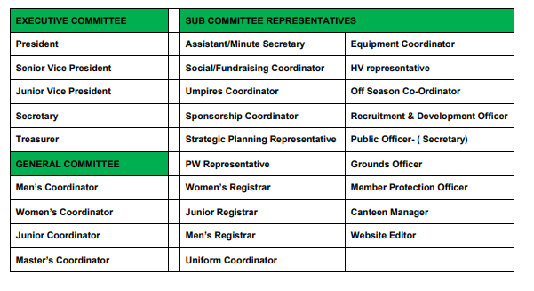
NOMINATION FOR 2021 MPHC COMMITTEE POSITION
First name: | Surname:
Committee Position:

Nominee’s phone number:

Nominee’s email address:

Nominator signature
(Please also print name) PH:
Seconder signature
(Please also print name) PH:
Date of Nomination:
Does Nominee know they have been nominated: YES NO
Please forward nomination to secretary@mphc.org.au before 5pm on 31 August 2020

